Motion Graphs
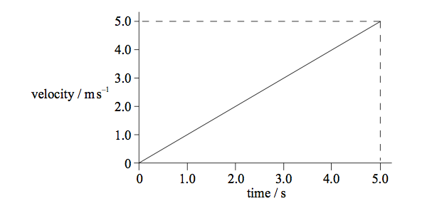
1. The velocity – time graph for an object accelerating in a straight line is shown below.

Which of the following is the change in displacement in the first 5 seconds?

A. 25.0 m B. 12.5 m C. 5.0m D. 1.0 m

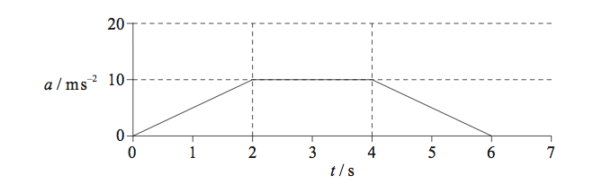
2. The graph below shows the acceleration of an object as time varies.

What is the magnitude of the change in the velocity of the object between 0 and 3 seconds?

A. 5 m/s B. 10 m/s C. 20 m/s D 30 m/s

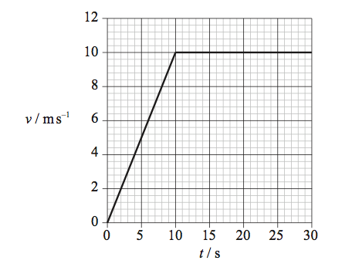
3. Patrick runs along a long straight track. The variation of his speed v with time t is is shown below.

After 25 seconds, Patrick has run 200m. What is correct at 25 seconds?

Instantaneous speed Average speed
A. 8 m/s 8 m/s
B. 8 m/s 10 m/s
C. 10 m/s 8 m/s
D. 10 m/s 10 m/s

4. An object falls vertically from rest until it reaches terminal velocity. Which of the following graphs is the distance-time graph for its motion?
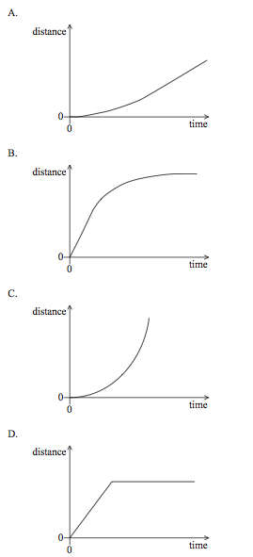

5. A car accelerates from rest. The acceleration increases with time. Which of the graphs shows the variation with time t of the speed v of the car?

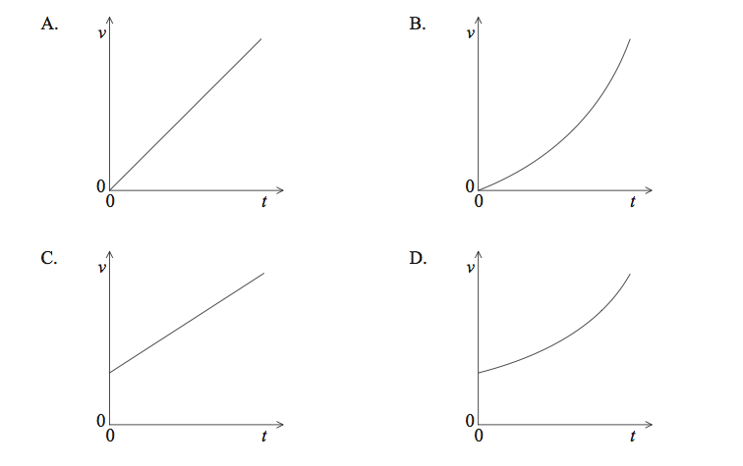

6. The following shows the graph of the acceleration of an object as it varies with time.
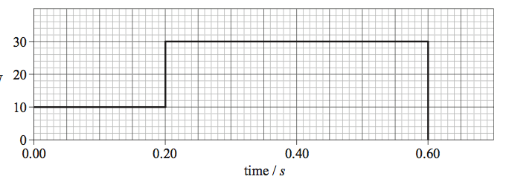

Acceleration
/ms⁻²

What is the speed of the object at 0.6 s? ________________________________

7. A stone is thrown vertically upwards from the surface of the Earth. Which of the following quantities will not become zero while the stone is in the air?
A. Speed B. Velocity C. Momentum D. Acceleration

8. An ice hockey puck is slid along ice in a straight line. The puck travels at t steady sped of 20 m/s and experiences no frictional force. How far does the puck travel in 2.5 s?
A. 5 m B. 8 m C. 25 m D. 50 m

9. Which of the following may be determined from a speed-time graph?
A. Displacement B. Distance C. Power D. Force

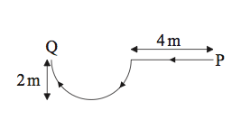
10. Samantha walks along a horizontal path in the direction shown. The curved part of the path is a semi-circle.

The magnitude of her displacement from point P to point Q is approximately

A. 2m B. 4 m C. 6 m D. 8m

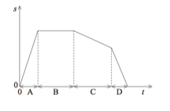
11. The graph below shows the variation with time t of the displacement s of a car. In which time interval is the speed the greatest?

12. The graph shows how the velocity of a particle varies with time.
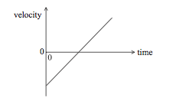

Which of the following graphs shows how the acceleration of the particle varies with time?

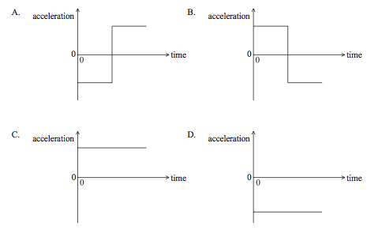

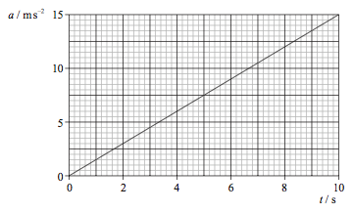
13. The graph shows the variation with time t of the accelertion a of a body that starts from rest.

Which of the following is the speed of the object after 10 seconds?

A 0.67 m/s B. 1.5 m/s C. 75 m/s D 150 m/s

14. The graph below shows the variation with time t of the displacement d of a body moving along a straight line.
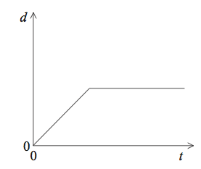

Which of the graphs best represents the variation with time t of the velocity v of this body?

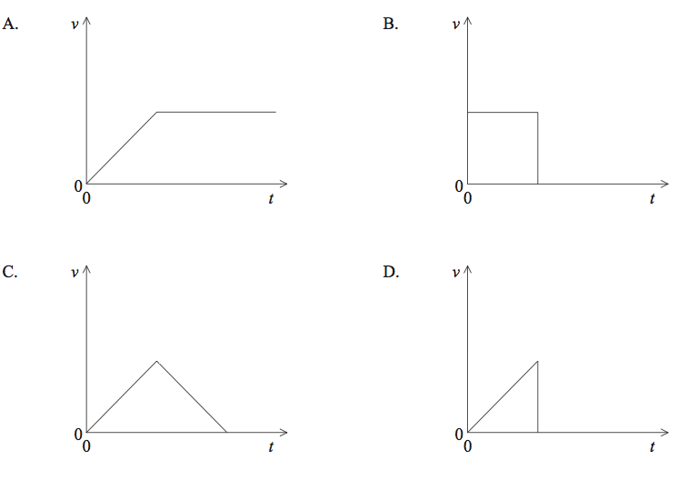

15. The graph below shows the variation with time t of the velocity v of a body moving along a straight line.
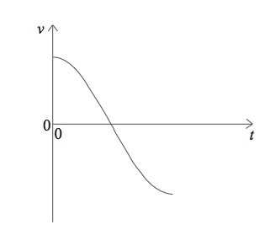
Which of the graphs best represents the variation with time t of the acceleration a of this body?
