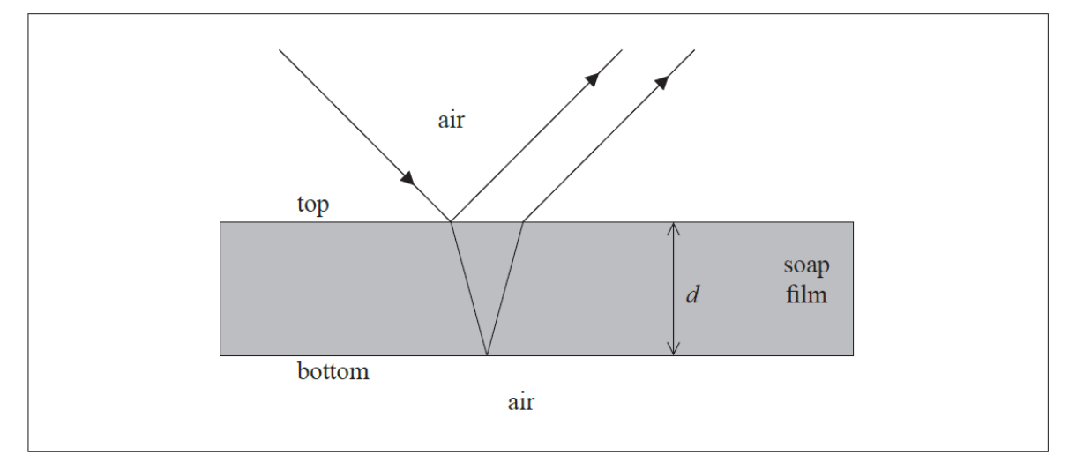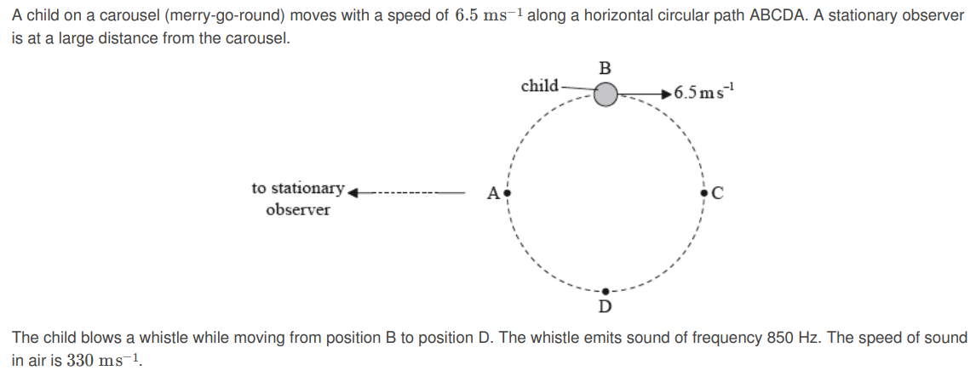

2. An ambulance is travelling at a speed of 28.0 ms along a straight road. Its siren emits a continuous sound of frequency 520 Hz. The ambulance is approaching a stationary observer. The observer measures the frequency of the note to be 566 Hz. Determine the speed of sound.

3. The star X has a companion star Y. The distance from Earth to the stars is 1.0×1018 m. The images of X and Y are just resolved according to the Rayleigh criterion by a telescope on Earth with a circular eyepiece lens of diameter 5.0×10-2 m.

(i) State what is meant by the statement “just resolved according to the Rayleigh criterion”.

(ii) The average wavelength of the light emitted by the stars is 4.8×10-7 m. Determine the separation of X and Y

Also be familiar with mass-spring and pendulum SHM calculations.

5.

a. Outline what is meant by the term

(i) coherent.

(ii) monochromatic.

b. State the phase difference between the light waves from the two slits that meet at Point B.

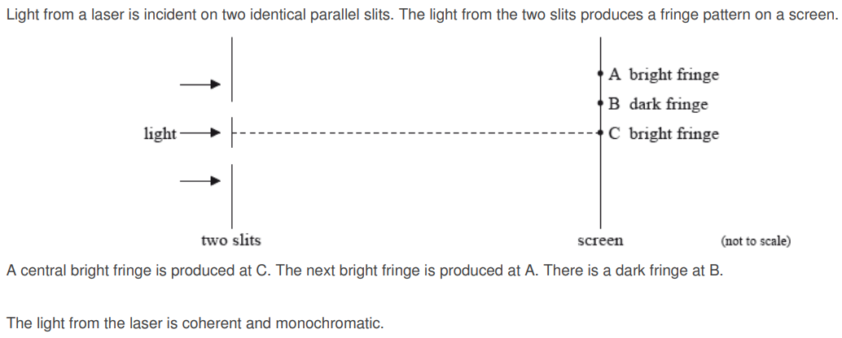

4.

1. Determine the minimum frequency of the sound heard by the observer.
2. Describe the variation of the frequency of the sound heard by the observer.

1. White light is incident normally on the soap film. The thickness d of the soap film is 225 nm and its refractive index is 1.34.

(i) Show that the longest wavelength of light λ in air for which the reflected rays destructively interfere is 603 nm.

(ii) Explain why the soap film will appear colored.

**IB Wave Phenomena Review**